Wiscat Request Manager – Overview

To access the Request Manager, click on the Staff Menu tab at the top left of the Home screen.
Then select ILL Admin.
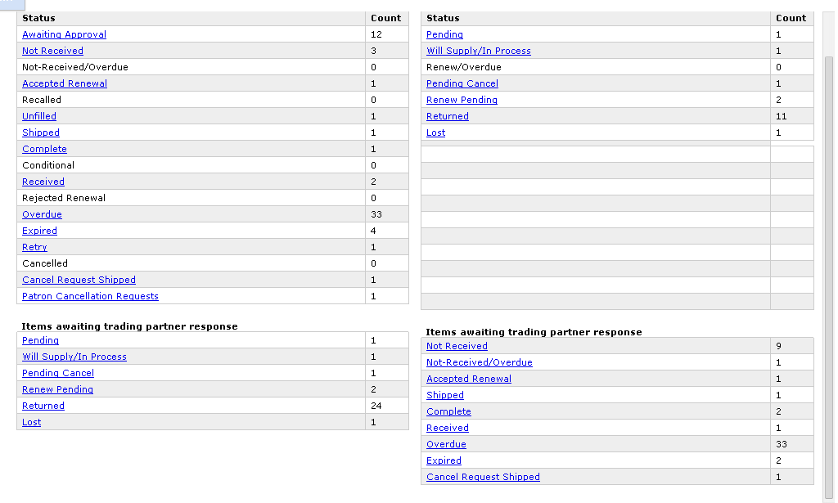

- A status category will be highlighted in the Request Manager if your library currently has requests in that category.

- To display a list of the requests in any status category, click on the status label. (Again, if you have any requests in a status category that status will be hilited and any hilited statuses can be clicked on).

- Any requests in your Request Manager with the following statuses may be “cleaned out” from your Request Manager view by updating them to “Delete”. This action will mark the request with a trash can. The request will be deleted during overnight processing when it will no longer be visible from your Request Manager.

  - CAUTION. This action eliminates a request and it cannot be undone.
  - Unfilled (after notifying patron of the reason the request could not be filled).
  - Lost (after resolving the issue with the borrower). Caution: try not to use this status at all. Currently the “Lost” status can not be changed once used (this is an issue AutoGraphics is aware of and might be able to fix sometime in the future). If possible, try to resolve the issue with the borrowing library without using the “Lost” status.
  - Cancelled.
  - Awaiting Approval (if the request is not going to be approved).

- Do not update requests in the Returned category. When the lender receives the item, they will update the request to “Check In” which will automatically update to (and display as) “Complete” status.

- Statuses below the red line (listed above for illustration only) are awaiting responses and generally do not need action from you.

  - On the Borrower side, these statuses provide information related to the requests your library has submitted as a borrower that are awaiting a response from the lenders.

  - On the Lender side, this section lists the requests you have received as a lender that are awaiting a response from the borrowers.

  - In some cases, an action may be taken by you as the Borrower for requests that have statuses displaying below the red line. Example: as the Borrower, you can cancel a request that is in “Pending” status at a lender.
Example: as the Lender, you can update a request in “Received” status to “Check In” if you’ve received the item back at your library
and the borrowing library forgot to update the request to “Returned”.
Wiscat Request Manager – Definitions of Basic Statuses

Basic Statuses as the Borrower:

Awaiting Approval | Request is awaiting approval before being sent to participant lenders.  Automatic Approval may be set by system Administration
Awaiting Lenders | Do not do anything with the request when it is in this status. This status should appear very temporarily between the item you submit (or “Approve”) a request) and when Wiscat has processed the request and sent it to a lender.
Not Received | Borrower has not received requested title from lender within the “days to supply”
Not Rec’d/Overdue | Lender has sent an Overdue notification to borrower for an item that has not yet been received by borrower.
Accepted Renewal | Lender allows borrower to renew loan.
Recalled | Lender needs title returned at once, before the due date.
Unfilled | Borrower’s request has not/will not be filled by any accessible lender at that time.
Shipped | Lender has shipped requested title to borrower.
Complete | Lender has received material returned by borrower (ILL transaction is complete. Requests in Complete status will automatically delete in 90 days.)
Conditional | Lender can supply the requested material subject to specified conditions. Borrower must respond ASAP.
Received | Borrower has received title from lender.
Rejected Renewal | Lender denies renewal of loan. Borrower must honor original due date.
Overdue | Borrower has not returned title to lender and due date has expired.
Expired | “Need by” date for the request has expired.
Retry | Borrower may retry the request if there are lenders that can supply after a specific date.
Cancelled | Request has been cancelled by borrower.
Cancel Request Shipped | Borrower wants request cancelled, but the lender has already shipped it. This status serves as notification that the patron does not want the item.
*Patron Cancellation Requests | *Only applicable if library has activated Patron request tracking.  Patron has submitted a cancellation request for an ILL request with a current status of  “Awaiting approval”, Pending or Will Supply/In Process”

Basic Statuses as the Lender:

Pending | Request has been received by lender, but has not yet been acknowledged.
Will Supply/In Process | Request has been accepted by lender, but has not been filled.
Renew/Overdue | Borrower requests loan renewal and due date for the item has expired.
Pending Cancel | Request is ready to be cancelled by borrower.
Renew Pending | Borrower requests loan renewal for title from lender.
Returned | Borrower has shipped title back to lender.
Lost | Borrower has informed the lender that the loaned item is lost. Lender declares the item Lost, by updating request status to “lost”. Caution: try not to use this status at all. Currently the “Lost” status can not be changed once used (this is an issue AutoGraphics is aware of and might be able to fix sometime in the future). If possible, try to resolve the issue with the borrowing library without using the “Lost” status.

*Undo Shipped: This status does not display as a category in the Request Manager. Rather, it is a status option that appears for lenders in the dropdown action menu for requests in “Shipped” status. It is only available for non-OCLC borrowers. Staff must have permission to use this status, set through ILL permissions in the User Admin screen.

