On Your Mark, Get Set, Read!
Week 2

Theme: Can’t Hide Our Kewaunee Pride

- Music

- Introduction
- Describe theme, “On Your Mark, Get Set, Read!”
- Describe 2016 Reading Challenge (show prize box)
- Book talk

- Stations

Station 1: Get your game face on
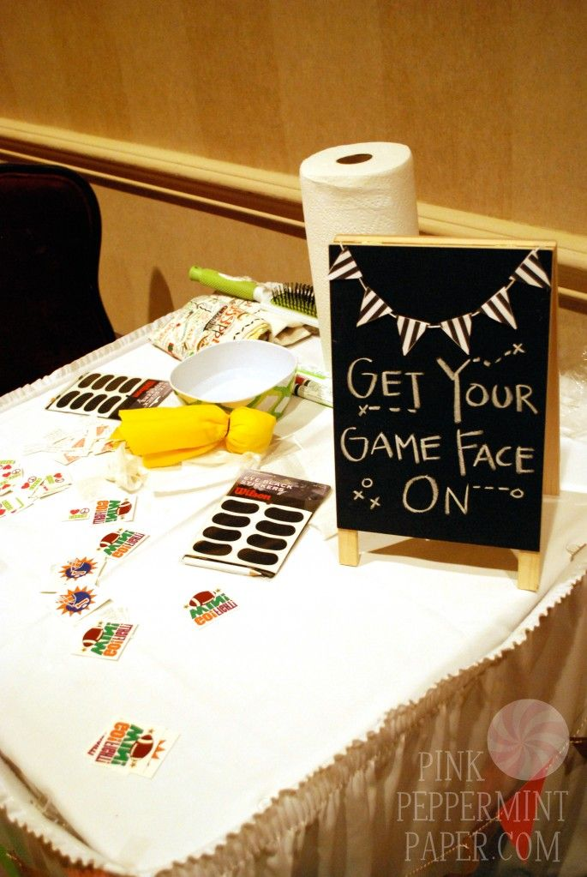

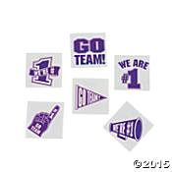
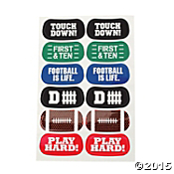

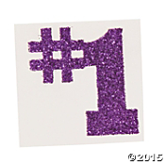

Station 2: Make a pennant
Station 3: Photo booth

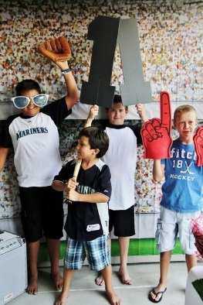

Oriental trading has a backdrop for $16.99
Can also use pompoms

- Activity
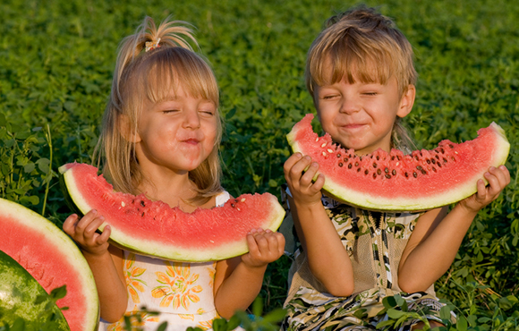

Cut watermelons into half-moons and give one to each member of your team. When you say go, the kids may begin eating. The player who finishes his watermelon first is the winner. Another variation of this game includes enforcing a "no-hands" rule. May want to use t-shirts from Quali-Ts.

- Snack
- Hand out Reading Challenge

On Your Mark, Get Set, Read!
Week 3

Theme: Teamwork Makes the Dream Work

- Music
- Introduction
- Collect Reading Challenges (they can pick prize at the end)
- Book Talk (include books on skeletal system)
- Watch “I Got Bones” on YouTube
Show YouTube video and print off lyrics
https://youtu.be/ja18CbJU6h8
Skeletal System Rap Song—“I Got Bones”

- Activity

Station 1:
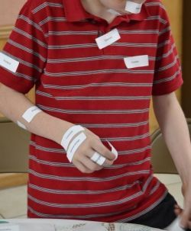

Station 2:
This is why today’s theme is about teamwork.
Pass the banana along with your feet (youth will have to be barefoot).
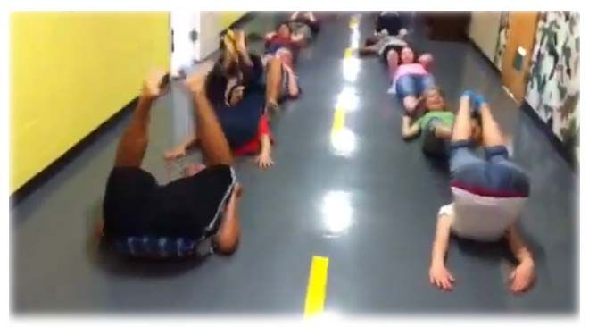

- Snack with lyrics from rap song
- Have pictures posted from photo booth from week #2 on a bulletin board. They can take picture home with them.

- Prize Box

On Your Mark, Get Set, Read!
Week 4
Theme: Go Big or Go Home
- Music
- Introduction
- Collect Reading Challenges
- Review skeletal system
- Book Talk (include books on muscular system)
- Today we are going to talk about the muscular system. Review some of the major muscles. We’re going to give them a workout.
- Activity
Station 1:
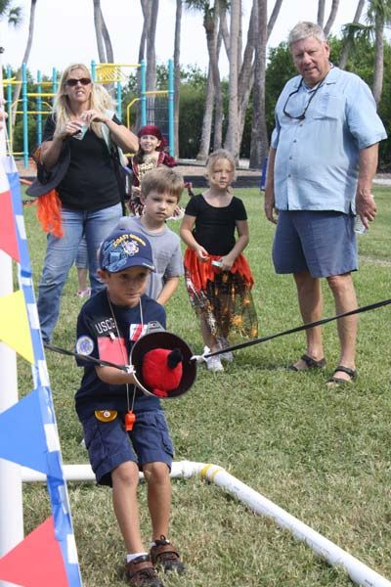
Can Mark Aulik build this? We can use water balloons or water sponges. Talk about the muscles they are using during this activity.

Station 2:
Jump rope contest winner gets to keep a jump rope
Station 3:
Rethink Your Drink (spoon out sugar content in front of them)
- Snack
- Prize Box
On Your Mark, Get Set, Read!
Week 5
Theme: All It Takes Is All You’ve Got
- Music
- Introduction
- Collect Reading Challenges
- Review muscular system
- Book Talk (include books on circulatory system)
- Today we are going to talk about the heart and the circulatory system.

Your heart is really a muscle. It's located a little to the left of the middle of your chest, and it's about the size of your fist. But the heart muscle is special because of what it does. The heart sends blood around your body. The blood provides your body with the oxygen and nutrients it needs. It also carries away waste. Your heart is sort of like a pump, or two pumps in one. The right side of your heart receives blood from the body and pumps it to the lungs. The left side of the heart does the exact opposite: It receives blood from the lungs and pumps it out to the body.

- Activity
Station 1:
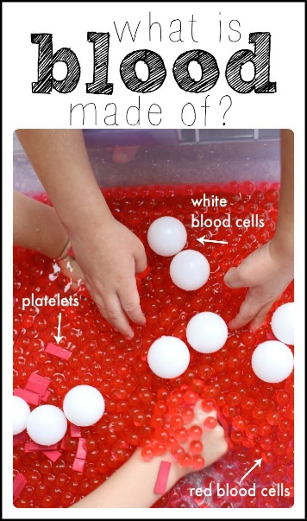

Here’s what you’ll need: a large plastic container (or sensory tub), red water beads, ping-pong balls (super cheap on Amazon), water, and red craft foam.

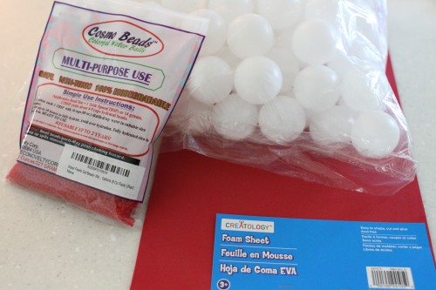
1. Follow the instructions on the packaging to hydrate the water beads. Go ahead and put them (and the water) into your plastic tub / sensory table to soak. Our package instructions indicated that once you add the water, it takes 10 hours for them to fully hydrate.

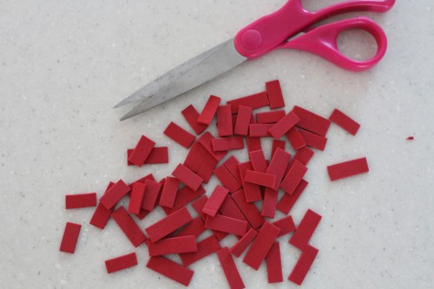
2. Cut the craft foam into small pieces to create your platelets.

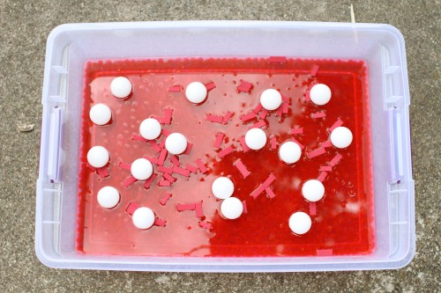
3. Put the “platelets” and several ping pong balls in your plastic tub.

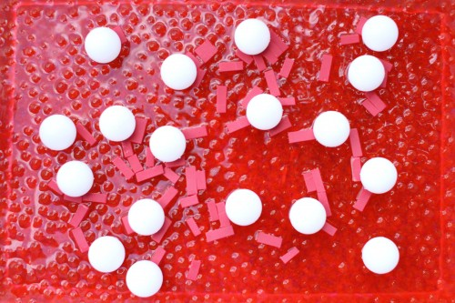

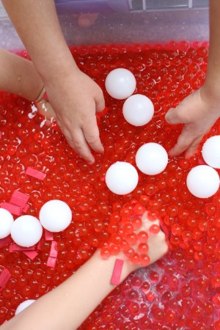
4. Let your kids explore for a while and then tell them the parts of blood:
Red water beads = Red Blood Cells (that carry oxygen)
Ping Pong Balls = White Blood Cells (that fight germs, bacteria, and viruses)
Craft Foam Pieces = Platelets (that help heal cuts)
Water = Plasma (helps the blood move through veins and arteries)
***Alternative: make it edible. Give each youth a ziplock bag. Red water beads could be a red sour cherry balls (that carry oxygen). Ping bong balls could be large white marshmallows. And platelets could be red licorice cut up. Kids would have to imagine those three things in plasma or a liquid.
Station 2:
Human Body Fact or Fiction
Station 3:
Plasma Relay

Water=Plasma, which helps the blood move through veins and arteries

Form two teams (youth can name their team). Each team stands in their own line, facing one direction. The person in the front holds a sponge. He/she dips the sponge into a big bucket of water, which is directly in front of them. They pass this sponge over their head to the person behind them. And it goes like this on down the line. The last person wrings the wet sponge into a pitcher (which is directly behind them) and then they run up to the front of the line (with the sponge) and begin all over again. The team to fill the pitcher first, wins.

- Snack with fine forgiveness
- Prize Box

On Your Mark, Get Set, Read!
Week 6
Theme: Loud and Proud
- Music: It’s gonna get loud right about now
- Introduction (review circulatory system. Today we are going to wrap up summer reading and use other muscles like the biceps, etc.)
- Collect Reading Challenges
- Book talk (include books on muscular system)
- Activity

Station 1:
Lean and Dabb video
Station 2:
Sign window like students do for Homecoming. E.g.: Thanks for coming to summer reading at the Kewaunee Public Library. We had a ball!
Station 3:
Rootbeer Floats

- Prize Box

Have additional “lawn games” out for them to play with

Additional lawn game ideas:

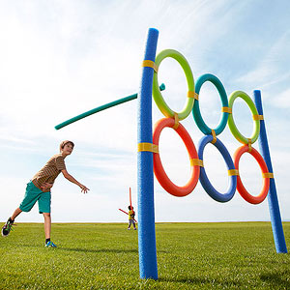

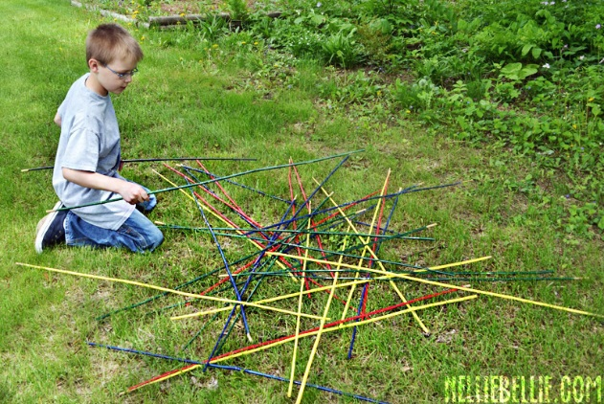
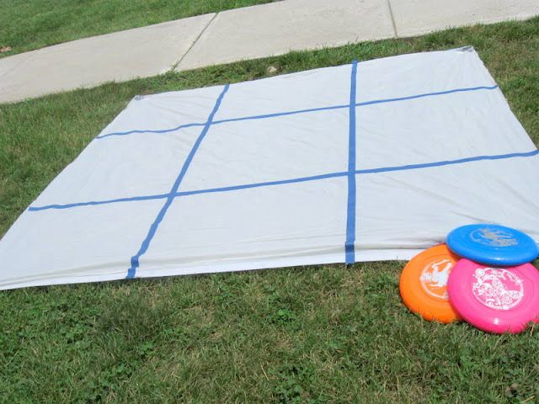

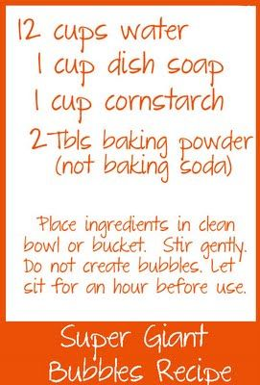

Ideas for prize box:

Big league chew
Dollar store activities (e.g.: jump ropes, etc.)
Water bottles
Movies (sports theme?)
Books (sports theme?)
Fine forgivness
Juice boxes

Theme music:

Jump around (Criss Cross)
Queen We will Rock you

